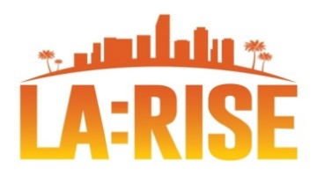
CalJOBSSM Correction Form & TA Request
SELECT PROGRAM: Regional LA:RISE LA RISE Youth Academy
REQUESTOR INFORMATION
Requested By |  | Phone Number |  | Email Address |  |  | Date
WORKFORCE PARTNER |  | SOCIAL ENTERPRISE PARTNER |  |  |  | OTHER
□ Sun Valley WSC (El Proyecto)  □ Sun Valley YSC (El Proyecto)  □ Hollywood WSC (MCS)  □ Northeast LA WSC (Goodwill)  □ Vernon Central LATTC WSC (CRCD)  □ West Los Angeles WSC (JVS)  □ West Los Angeles YSC – UCLA YSC  □ Central LA - AYE YSC (Catholic Charities)  □ West Adams WSC (AADAP)  □ Pacoima Northeast Valley WSC (Goodwill) |  | □ Center for Employment Opportunities  □ Center for Living and Learning  □ Chrysalis Enterprises  □ CRCD Enterprises  □ Downtown Women’s Center  □ Goodwill SE  □ GRID Alternatives  □ Homeboy Industries  □ LA Conservation Corps  □ LA LGBT Center  □ New Earth Organization  □ YWCA Digital Learning Academy |  |  |  | □ Other:
PARTICIPANT INFORMATION
Participant Name |  |  | User Name
User ID |  |  | Last 4 Digits SSN
REASON FOR CORRECTION / TECHNICAL ASSISTANCE REQUEST
CITY MIS USE ONLY
Analyst Assigned |  |  |  |  | Date
Status
□ Approve | □ Deny
Notes

SUBMISSION INFORMATION
To: LA City MIS Section Email: celene.heredia@lacity.org & emoli.mendez@lacity.org
Subject: Correction Form Fax: (213) 744-9326
Last Revised 6/30/21

